

SENTIMENT ANALYSIS USING ML

**Group Project Team 4**



***IS-623 Final Document***

***Information systems Design and Development***

**Table Of Contents 1.0**

* Introduction
* Overview of Four Chapters
* Reasoning for choosing the topics
* Topic 1: Chapter 1: The Systems Development Environment
* Topic 2: The Origins of Software
* Topic 3: Project Management for Information Systems
* Topic 4: System Implementation
* A Focus on Supervised and Unsupervised Learning, RNNs, and CNNs
* Sentiment Analysis Model Construction: Steps, Challenges, and Limitations
* Enhancing Precision and Interpretability of Sentiment Analysis Models
* Sentiment Analysis: Evaluating Machine Learning Algorithms for Categorizing Text Data into Positive, Negative, and Neutral Sentiments
* Statement of project importance
* Conclusions/Statements on Machine Learning Sentiment Analysis
* Artifacts
* Reference List

Introduction

Determining the sentiment or emotional tone underlying a piece of text, such a review, remark, or social media post, is the intriguing and important task of sentiment analysis, sometimes referred to as opinion mining, in the discipline of natural language processing (NLP). Sentiment analysis is now more crucial than ever for organizations, marketers, and academics to understand public opinion, customer feedback, and brand impression due to the exponential expansion of social media and online reviews. A useful tool for sentiment analysis in recent years has been machine learning (ML) methods' capacity to automatically recognize patterns and extract features from massive datasets. In order to accurately categorize texts into positive, negative, or neutral sentiment categories, ML-based sentiment analysis algorithms have demonstrated promising results. As a result, they are invaluable in a variety of applications, including market research, customer service, and social media monitoring.

The real-world applications of sentiment analysis using ML include social media sentiment analysis, political sentiment analysis, brand monitoring, sentiment-based product recommendation, and customer feedback analysis. 

In this group project, we will delve into the many methods, difficulties, and uses of ML in sentiment analysis as we investigate the issue of sentiment analysis utilizing this technology. We'll look at several machine learning (ML) algorithms, such supervised and unsupervised learning, as well as deep learning methods like recurrent neural networks (RNNs) and convolutional neural networks (CNNs), which have been extensively used to sentiment analysis. We will also look at the procedures involved in creating a sentiment analysis model, such as feature extraction from the data, model training, and assessment.

The difficulties and restrictions of sentiment analysis will also be covered, including how to cope with sarcasm, irony, and ambiguity as well as bias and subjectivity in sentiment categorization.

We will also look into methods like feature engineering, ensemble methods, and explainable AI for improving the precision and interpretability of ML-based sentiment analysis models.

Last but not least, we'll explore the many ML-based sentiment analysis applications, which span everything from politics and social sciences to business and marketing. We will look at the applications of sentiment analysis in social media sentiment analysis, political sentiment analysis, brand monitoring, sentiment-based product recommendation, and customer feedback analysis. We will also go into moral issues and the consequences of sentiment analysis in a number of areas, including privacy, prejudice, and fairness.

Six machine learning and NLP enthusiasts from our company set out on a group project to investigate the exciting field of sentiment analysis using various machine learning techniques.

In this research, our goal was to examine text data, categorize it as having a positive, negative, or neutral sentiment, and assess how well various machine learning algorithms performed at accurately classifying sentiment.

We will give a summary of our group effort on sentiment analysis using machine learning in this essay. We'll talk about why we chose this subject, what we wanted to accomplish, how we went about doing it, and what the main conclusions and learnings were. We will also discuss the problems we had while working on the project, as well as the contributions made by each team member. We'll wrap up by discussing the importance of our project and potential real-world uses for it.

# **Motivation:**

The growing importance of sentiment analysis in today's data-driven environment served as the inspiration for our group research on sentiment analysis using machine learning. Businesses and organizations are continuously looking for new methods to use the text data generated by social media, customer reviews, and other internet sources to obtain insights into consumer thoughts and preferences. This massive volume of text data may be automatically categorized and analyzed with the use of sentiment analysis, which gives a potent solution and useful data for decision-making.

The developments in machine learning and natural language processing methods, which have created exciting new opportunities for sentiment analysis, also served as inspiration for us. We wanted to investigate how well machine learning might predict sentiment from text data given the availability of big labeled datasets, better algorithms, and more complex models. We were keen to apply our expertise in machine learning and natural language processing to a practical issue that has applications and ramifications in the real world.

We hope to get a thorough grasp of sentiment analysis using ML through this group project, as well as how it can be used to glean insightful information from text data in practical settings. We want to contribute to these efforts by examining the many methods, issues, and applications of ML in sentiment analysis.

# **The four chapters for the group project on sentiment analysis using machine learning are as follows:**

**Chapter 1: The Systems Development Environment** – This chapter serves as an introduction to the general systems development environment, which includes the setting in which sentiment analysis using machine learning occurs. The basis for comprehending the next chapters may be laid by its coverage of the fundamentals of natural language processing (NLP) and machine learning. Moreover, it can go through the value of sentiment analysis in the current data-driven world, its difficulties and potential benefits, and the applicability of ML-based strategies to overcome these difficulties.

**Chapter 2: The Origins of Software** - This chapter might concentrate on sentiment analysis's historical evolution and how it has changed through time. It may examine the origins of ML-based approaches and how they developed from earlier approaches and methodologies for sentiment analysis, such as rule-based systems and dictionary-based methods. It might go through significant developments in the field of sentiment analysis research as well as significant contributions. Also, this chapter might showcase the most recent developments and innovations in the field of sentiment analysis utilizing machine learning.

**Chapter 3: Project Management for Information Systems** - This Chapter can help with project management for sentiment analysis using ML. It might go over the many phases of creating a sentiment analysis system, such as project planning, resource allocation, risk management, and project execution. Also, it may emphasize how crucial it is for team members to work together and coordinate their efforts while working on a project together, as well as how good project management can result in the efficient application of ML approaches for sentiment analysis.

**Chapter 13: Group Project for System Implementation** - The practical features of constructing a sentiment analysis system utilizing machine learning can be the main topic of this chapter. It can go over the procedures required in building a sentiment analysis model, such as feature extraction from the data, model training, and assessment. Moreover, it may discuss the difficulties and factors to be taken into account while dealing with enormous datasets, choosing suitable ML algorithms, and enhancing model performance. The ethical issues surrounding sentiment analysis, such as prejudice, fairness, and privacy, can also be covered in this chapter, along with solutions on how to apply them.

# **Reasoning for choosing these topics:**

**1. Wide-ranging coverage**: The topics covered in these four chapters, which range from the foundations of system development and the history of software through project management and system implementation, cover a variety of machine learning-based sentiment analysis techniques. This enables thorough discussion of the subject and offers a thorough grasp of sentiment analysis and its use in practical situations.

**2. Relation to group project**: These subjects are closely related to the group project on sentiment analysis using machine learning since they give the background and context required to comprehend the subject and put a sentiment analysis system into practice. These can work as building blocks for the group project, offering the conceptual underpinning and useful direction for carrying out the study and putting the sentiment analysis system in place.

**3. Practical relevance**: Given the importance of sentiment analysis as a tool for businesses, marketers, and academics to analyze consumer feedback, public opinion, and brand perception in the age of social media and online reviews, these themes are both practical and current. The subjects are helpful for the group project since they address both the theoretical and practical components of ML-based techniques as well as the theoretical aspects of sentiment analysis.

**4. Current trends and advancements**: These subjects cover discussions on the most recent methods, scientific discoveries, and moral issues in sentiment analysis utilizing machine learning. As a result, the group project may be current with the most recent advancements in the field and provide cutting-edge and pertinent research.

**5. Focus of the group project**: These subjects relate to the group project's emphasis on sentiment analysis using machine learning, offering a natural progression of information from the foundations of systems development and the history of software through project management and system implementation. As a result, the chapters are guaranteed to be strongly tied to the group project and add to its overall coherence and significance.

Chapter Choices

# **Chapter 1: The Systems Development Environment**

Companies and organizations are continuously looking for creative ways to harness the power of technology to obtain a competitive edge in today's digital world. Machine learning (ML)-based sentiment analysis is one such field that has attracted a lot of attention. To detect the sentiment or emotional tone associated with the material, sentiment analysis, sometimes referred to as opinion mining, entails extracting subjective information from text data, such as social media postings, customer reviews, and online comments. An overview of the systems development environment and how it relates to the group project on sentiment analysis using ML is given in this chapter. The methods, equipment, and methodologies needed to create and put into use information systems are all included in the systems development environment. The systems development life cycle (SDLC), which acts as a framework for developing new information systems, is made up of a number of clearly defined phases. System planning, system analysis, system design, system implementation, system maintenance, and system disposal are the six stages that commonly make up the SDLC. Each phase includes a unique set of tasks, products, and deadlines that must be met in order for the systems development process to be successful.

**System Design**:

System planning, which is the first stage of the SDLC, entails determining the need for a new information system and specifying its goals. During this stage, tasks including completing feasibility studies, establishing a business case to support the need for the new system, outlining the project's goals and objectives, and evaluating the resource needs. The system planning phase of the group project on sentiment analysis using ML would entail identifying the precise goals of the sentiment analysis system, comprehending the needs and resources for the project, and assessing the project's viability in terms of technical, financial, operational, and scheduling aspects.

**System Analysis**:

Gathering and documenting user requirements, examining current systems, and spotting possible problems or constraints are all part of the system analysis process. Understanding the system's existing state and defining the intended state are the goals of this phase, which also identifies the functional and non-functional needs of the new system. The system analysis phase of the group project would entail comprehending the needs of the sentiment analysis system, such as the kind of text data to be analyzed (for example, social media posts, customer reviews), the sentiment categories to be taken into account (for example, positive, negative, and neutral), and the accuracy and performance needs of the ML algorithms to be used.

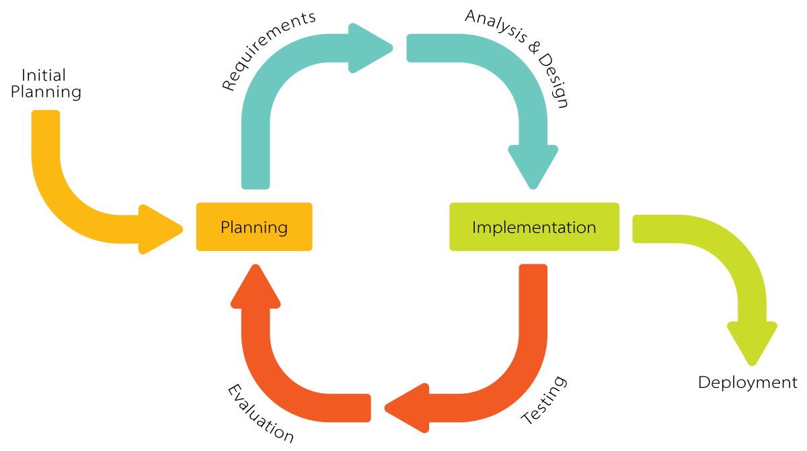

**System Design**:

Based on the requirements acquired during the system analysis phase, a blueprint for the new information system is created during the system design phase. The system's architecture, data models, user interfaces, and system interfaces are all designed at this phase. The system design part of the group project would entail creating the sentiment analysis system's architecture, which would include the ML algorithms to be utilized, the data models to store and process the text data, and the user interfaces for entering and presenting the sentiment analysis findings.

**System Implementation:**

Based on the design requirements created in the earlier phases, the system implementation step include creating the real information system. To make sure the system works as planned, this phase involves tasks including coding, testing, and debugging. The system implementation portion of the group project would entail developing and implementing the machine learning algorithms for sentiment analysis, combining the data models and user interfaces into a usable system, and testing the system to assure correctness and performance.

**System Maintenance**:

When the information system has been installed, system maintenance entails assuring its continued dependability and performance. To solve issues, boost performance, and react to shifting business demands, this phase also involves monitoring, troubleshooting, and upgrading the system. In the context of the group project, the system maintenance phase would entail keeping an eye on how the sentiment analysis system is performing, figuring out and fixing any problems or limitations, and updating the system as necessary to maintain its efficacy and accuracy in determining sentiment from text data.

**System Disposition**:

The SDLC's last step is retiring or replacing the information system when it is no longer required or pertinent. This phase entails tasks including assessing the system's performance, figuring out when it will become obsolete, and making plans for its replacement or retirement. The group project's system disposition phase would entail assessing the effectiveness and applicability of the sentiment analysis system, taking into account things like shifting business needs, technological advancements, and data privacy concerns, and deciding whether to keep using the system or retire it.

The systems development environment gives developers and implementers of information systems, such as the team project on sentiment analysis using ML, a structured framework for creating and implementing information systems. The group project may provide a systematic and structured approach to constructing a trustworthy and efficient sentiment analysis system by adhering to the phases of the SDLC, such as system planning, system analysis, system design, system implementation, system maintenance, and system disposal.

# **Chapter 2: The Origins of Software - Next Steps in Group Project for Current Trends**

Our group project has finished studying Chapter 1 of the Systems Development Environment and is moving on to Chapter 2, which explores the history of software. It is essential to comprehend how software has changed over time and the current trends that are shaping the industry as we examine the history of software development. This part will detail the subsequent stages for our group project with an emphasis on the most recent developments in software development utilizing the ideas covered in Chapter 2 as foundation.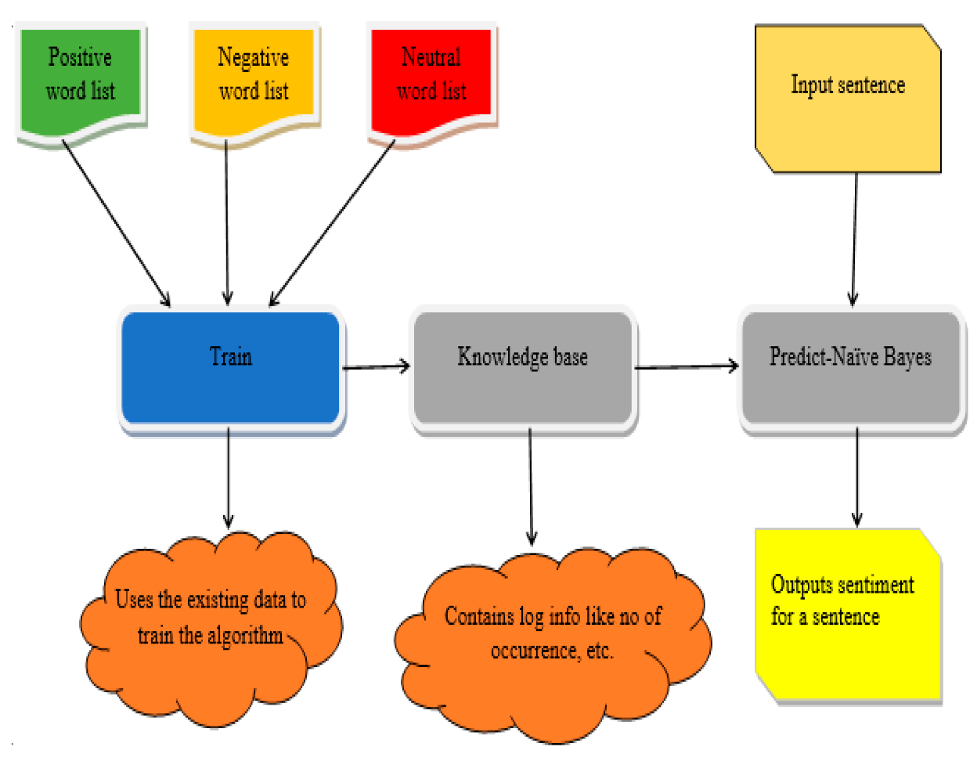

**Step 1**:

Investigating Early Software Development Milestones It is crucial to first know the historical turning points that have molded the profession in order to completely comprehend the present trends in software development. We will start our group project by doing extensive study on the history of software, including how it changed from punch cards and batch processing to high-level programming languages and graphical user interfaces. We'll look at significant advancements like the invention of the first compilers, the adoption of object-oriented programming, and the rise of open-source software, among other things. We will be better able to examine and decipher the present trends in the industry if we are aware of the historical background of software development.

**Step 2**:

Recognizing Current Software Development Patterns When we have a firm grasp of the historical background of software, our group project will turn its attention to determining the most recent developments in the industry. The most recent developments and advances in software development, including but not limited to the following fields, will be thoroughly researched by us:

1. **Agile Development**:

Due to its adaptable and collaborative approach to software development, agile approaches like Scrum and Kanban have significantly increased in popularity in recent years. We will examine the tenets and methods of agile development, as well as how it affects teamwork, project management, and customer satisfaction.

1. **DevOps**:

Emphasizing cooperation and automation between software developers and IT operations teams, DevOps, which mixes development and operations, has become a crucial trend in software development. We will look at the tenets and advantages of DevOps, such as automated testing, infrastructure as code, and continuous integration and deployment.

1. **Cloud Computing**:

The way software is created, used, and maintained has been completely transformed by cloud computing. We'll examine the cloud computing concepts of infrastructure as a service (IaaS), platform as a service (PaaS), and software as a service (SaaS), as well as how they affect the scalability, affordability, and creation of software.

1. **Artificial intelligence (AI) and machine learning (ML)**:

By allowing intelligent applications, predictive analytics, and automated decision-making, AI and ML technologies are revolutionizing the world of software development. We'll look at how AI and ML are used in software development for tasks like recommendation engines, computer vision, and natural language processing.

1. **Internet of Things (IoT)**:

By allowing smart devices and systems and linking common things to the internet, the IoT has created new opportunities for software development. We will look into the ideas behind the Internet of Things, including how it affects security, data analytics, and software development.

1. **Web and mobile development**:

Our group project will examine the most recent developments in mobile and online development, such as responsive design, progressive web apps, and cross-platform development frameworks. Mobile and web applications have become omnipresent in today's digital world.

**Step 3:**

Examining the Consequences of Present Trends Our group project will examine the effects of the current trends in software development on various facets of the industry after we have recognized them. We'll look at how these changes affect project management, team dynamics, software quality, scalability, security, and user experience. We will also take into account the ethical, legal, and social ramifications of these developments, including concerns about data security, privacy, bias in AI and ML algorithms, the workforce, and the labor market.

**Step 4:**

Examining Case Studies and Best Practices Our group project will explore best practices and case studies that highlight actual instances of successful implementations in order to obtain practical insights into the current trends in software development.

To comprehend how these trends have been utilized in various contexts and their results, we will analyze case studies from various industries, including software startups, established enterprises, governmental organizations, and non-profit organizations. We will also talk about industry leaders and thought leaders in the field of software development's best practices and lessons gained.

**Step 5**:

Presenting Results and Suggestions Our group project will synthesize our conclusions and suggestions after completing in-depth research and analysis into a complete report or presentation. Our colleagues and stakeholders will benefit from our knowledge of the most recent developments in software development, their effects, and best practices. We may suggest approaches for incorporating these trends into software development projects, potential obstacles to be overcome, possible solutions, and areas that merit more study and investigation.

We'll learn more about how software development has changed and where it's going as we continue working on our group project, which involves investigating the history of software and the most recent developments in the industry. We will be well-equipped to navigate the dynamic environment of software development and contribute to the field's advancement by investigating historical turning points, spotting contemporary trends, delving into their implications, talking about best practices and case studies, and presenting our findings and suggestions.

**Chapter 3: Project Management for Information Systems**

After comprehending the history of software in Chapter 2, the group project's next step is to concentrate on project management of the information systems. The creation and deployment of information systems must be managed effectively if they are to be successful. We will explore all facets of managing an information systems project in this chapter, including project planning, organizing, executing, monitoring, and controlling. In this lesson, we'll look at the best practices, obstacles, and approaches for managing information systems projects and see how they relate to our group project.

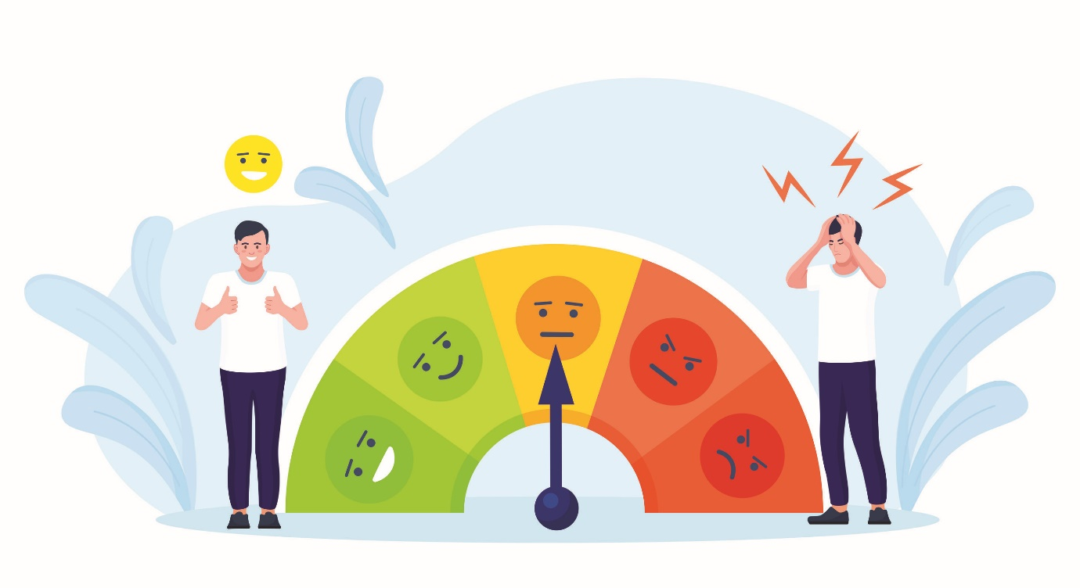

**Project Planning**:

The creation of an extensive project plan is the first stage in managing an information systems project. The project's goals, deliverables, scope, and deadlines must all be specified. We must design a communication strategy, identify the stakeholders, and clearly define the project's aims and objectives as a group. We must also specify the duties and responsibilities of every team member and then distribute resources appropriately. The project's hazards must also be taken into account, and a backup plan must be created to reduce them. We can make sure that everyone in the team is on the same page and knows exactly where the project is headed by developing a detailed project plan.

**Organizing the Project Team**:

Managing an information systems project requires careful team organization. We must decide as a team what tasks and duties each team member will do based on their qualifications, experience, and availability. In order to eliminate uncertainty and guarantee effective communication among team members, it is crucial to create a clear chain of command and decision-making procedure. In order to discuss the project's advancement, handle any difficulties, and reach decisions as a team, we must schedule frequent team meetings. We can shorten the project workflow and encourage team communication by structuring the project team well.

**Project Execution**:

When the project plan has been established, the project must be carried out in accordance with the specified scope, dates, and deliverables. We must all work together to keep a careful eye on the project's development and make sure that everyone is carrying out their assigned tasks. We must keep track of the project milestones, properly manage our resources, and address any problems or disputes that may come up while the project is being carried out. During this phase, team members must regularly communicate and coordinate in order to keep the project on track and achieve its goals.

**Monitoring and Control**:

Keeping an eye on the project is a continuous activity that calls for constant attention. We as a team must monitor the project's development in relation to the scheduled deliverables and milestones. We must keep an eye on the caliber of the work, timeliness, and resource use. We must take remedial steps to put the project back on track if any deviations are found. In order to account for changes in needs or scope, the project plan must also be regularly reviewed and updated as necessary. To make sure the project is moving along as intended and to take proactive steps to remedy any concerns, effective monitoring and controlling are crucial.

**Project risk management** :

is a critical component of information systems project management. We must all work together to identify possible risks related to our project and create a risk management strategy. This entails carrying out an extensive risk assessment, examining the possibility and consequences of each risk, and creating mitigation plans. As the project develops and new risks appear, the risk management strategy has to be periodically reviewed and updated. We may lessen the impact of unanticipated circumstances and assure the project's success by actively controlling project risks.

The management of an information systems project involves thorough planning, organizing, carrying out, monitoring, and regulating. As a team, we must develop a thorough project plan, set up the project team, carry out the project as planned, keep track of and manage the project's progress, and successfully manage risks. We can guarantee that our group project is effectively managed and finished by using the best practices and tactics outlined in this chapter. In order to create and deploy information systems, as well as to meet deadlines, achieve project goals, and provide high-quality outputs, effective project management is needed. In order to successfully manage our information systems project and assure its success as we go forward with our group project, we will utilize the knowledge and abilities we have received from this chapter.

# **Chapter 13: Group Project for System Implementation**

The system implementation phase of a group project comes after Chapter 3 on Managing the Information Systems Project and is extremely important for the outcome. The team collaborates throughout this stage to implement the planned solution and make it user-friendly. This chapter focuses on the crucial elements of system implementation, including the procedures to follow, potential difficulties, and effective execution strategies.

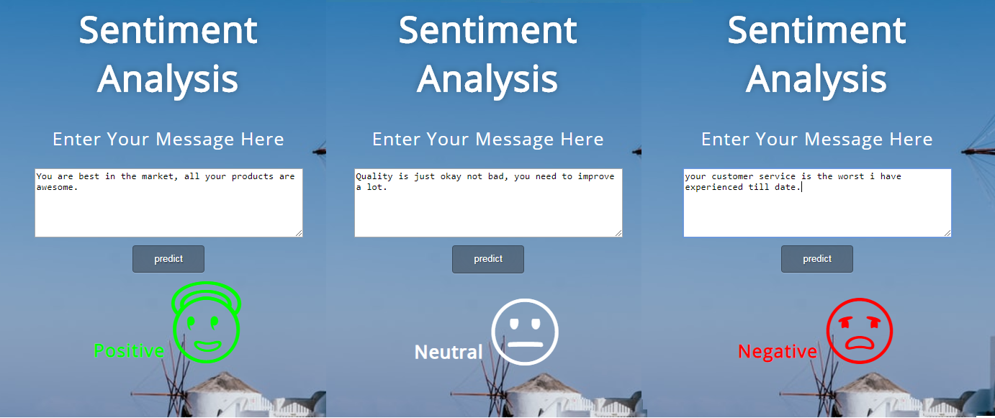

Steps for System Implementation 1 There are a number of crucial tasks that must be properly planned and carried out throughout the system installation phase. These actions comprise:

* 1. **Creation of a Comprehensive Implementation Plan:**

The group project team must develop a thorough implementation plan that details the particular duties, due dates, and obligations of each team member. This strategy should take into account elements like resource allocation, means of communication, and methods for risk management.

* 1. **Hardware and Software Installation:**

When the implementation strategy has been put in place, the team must install the appropriate hardware and software to complete the task. Setting up servers, databases, network setups, and software applications may be necessary for this.

* 1. **Data Migration and Integration:**

The group must make sure that all pertinent data is appropriately transferred from the old system to the new one. Data scrubbing, validation, and system integration may be required for this. Throughout this procedure, data security and privacy should also be taken into account.

* 1. **Testing and Quality Assurance:**

To make sure the system works as intended and satisfies the specified criteria, the group project team must carry out exhaustive testing and quality assurance checks. Functional, performance, security, and user acceptability testing may be included in this.

* 1. **User Training:**

In order to guarantee that end users are competent in utilizing the new system, user training is essential. As end users adapt to the new solution, the team should provide training materials, hold training sessions, and offer continuing support.

* 1. **Transition and Go-Live**:

The team may go on with the real system transition and go-live when the system has been extensively tested and end users have received training. Live operations may need to be transferred from the outdated system to the new one, and the system's performance during the early phase may need to be continuously monitored.

1. **Problems in Implementing the System To achieve a successful implementation**

a group project's system implementation phase may run into a number of obstacles that must be proactively overcome. among the typical difficulties are:

* 1. **Technical Difficulties:**

While installing hardware and software, moving data, and integrating systems, there may be technical difficulties. Compatibility problems, setup mistakes, and software defects may be among these difficulties. To quickly handle these difficulties, the team has to have a strong technical support infrastructure.

* 1. **Difficulties with Change Management**:

Putting in place a new system frequently calls for adjustments to staff roles, workflows, and business processes. Significant difficulties may arise from user resistance to change, a lack of user acceptance, and inadequate communication. By incorporating stakeholders, communicating clearly, and resolving concerns, the team must successfully manage change.

* 1. **Resource Constraints**:

The implementation of a system may be hampered by a lack of funds, skilled labor, or time. The group must actively manage resources and make sure they are distributed according to project requirements.

* 1. **Risk Management Challenges**:

The effectiveness of the project might be impacted by risks related to system deployment, such as data breaches, system failures, and operational interruptions. To reduce their influence on the implementation process, the team must proactively identify, evaluate, and manage risks.

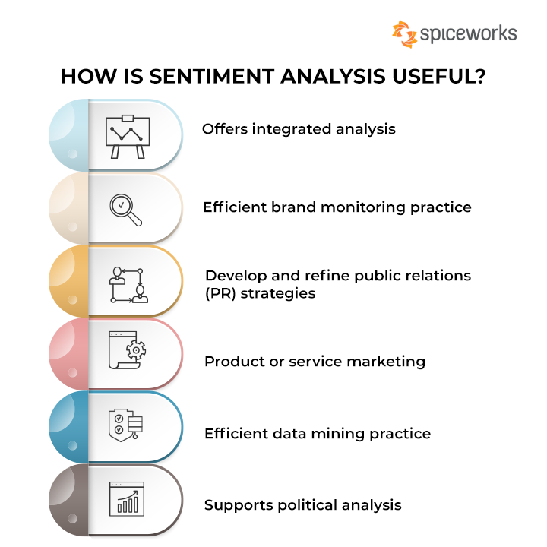

1. **Recommended Techniques for System Implementation**

The group project team should adhere to the following best practices to guarantee a successful system implementation:

* 1. **Strong Project Management**:

For effective system installation, a well-defined project management methodology, including a complete implementation plan, is essential. Setting defined project objectives, defining schedules, allocating roles, and periodically assessing progress are all part of this.

* 1. **Cooperation and Communication**:

Throughout system deployment, effective collaboration and communication among team members is critical. This involves holding frequent team meetings, providing progress reports, and maintaining open communication channels for problem resolution and decision-making.

* 1. **Extensive Testing and Quality Assurance:**

Comprehensive testing and quality assurance methods should be performed to discover and resolve any issues before the system is put into production. Functional testing, performance testing, security testing, and user acceptability testing are all performed to ensure that the system satisfies the specified criteria.

* 1. **Change Management**:

To smoothly transition from the old system to the new solution, proactive change management is crucial. This entails incorporating stakeholders, supplying end users with training and assistance, and resolving any worries or change resistance.

* 1. **Risk Management**:

To identify, evaluate, and reduce risks related to system installation, a thorough risk management plan should be in place. This entails foreseeing possible risks, creating backup plans, and keeping an eye on hazards all throughout the implementation process.

* 1. **Continuing Support**:

A successful deployment depends on providing end users with continued assistance once the system goes live. This include attending to any problems or inquiries, offering ongoing training, and keeping an eye on the system's performance to guarantee smooth operations.

The system implementation stage of a group project is essential for the outcome. It entails a number of processes, including the development of an implementation strategy, the installation of hardware and software, the migration of data, testing, the instruction of end users, and the switchover to the new system. Proactively addressing challenges including technological difficulties, change management, resource limitations, and risk management is necessary. The group project team may boost the likelihood of a successful system installation by adhering to best practices including strong project management, excellent cooperation and communication, rigorous testing and quality assurance, change management, risk management, and continuous support.

# **As mentioned in the introduction, this section of the project aims to provide a concise overview of the topics that will be elaborated upon in further detail.**

# **Exploring Various Machine Learning Algorithms for Sentiment Analysis: A Focus on Supervised and Unsupervised Learning, RNNs, and CNNs**

A area of natural language processing (NLP) called sentiment analysis, commonly referred to as opinion mining, uses machine learning (ML) algorithms to ascertain the sentiment or emotional tone indicated in text data, such as reviews, social media postings, or customer feedback.

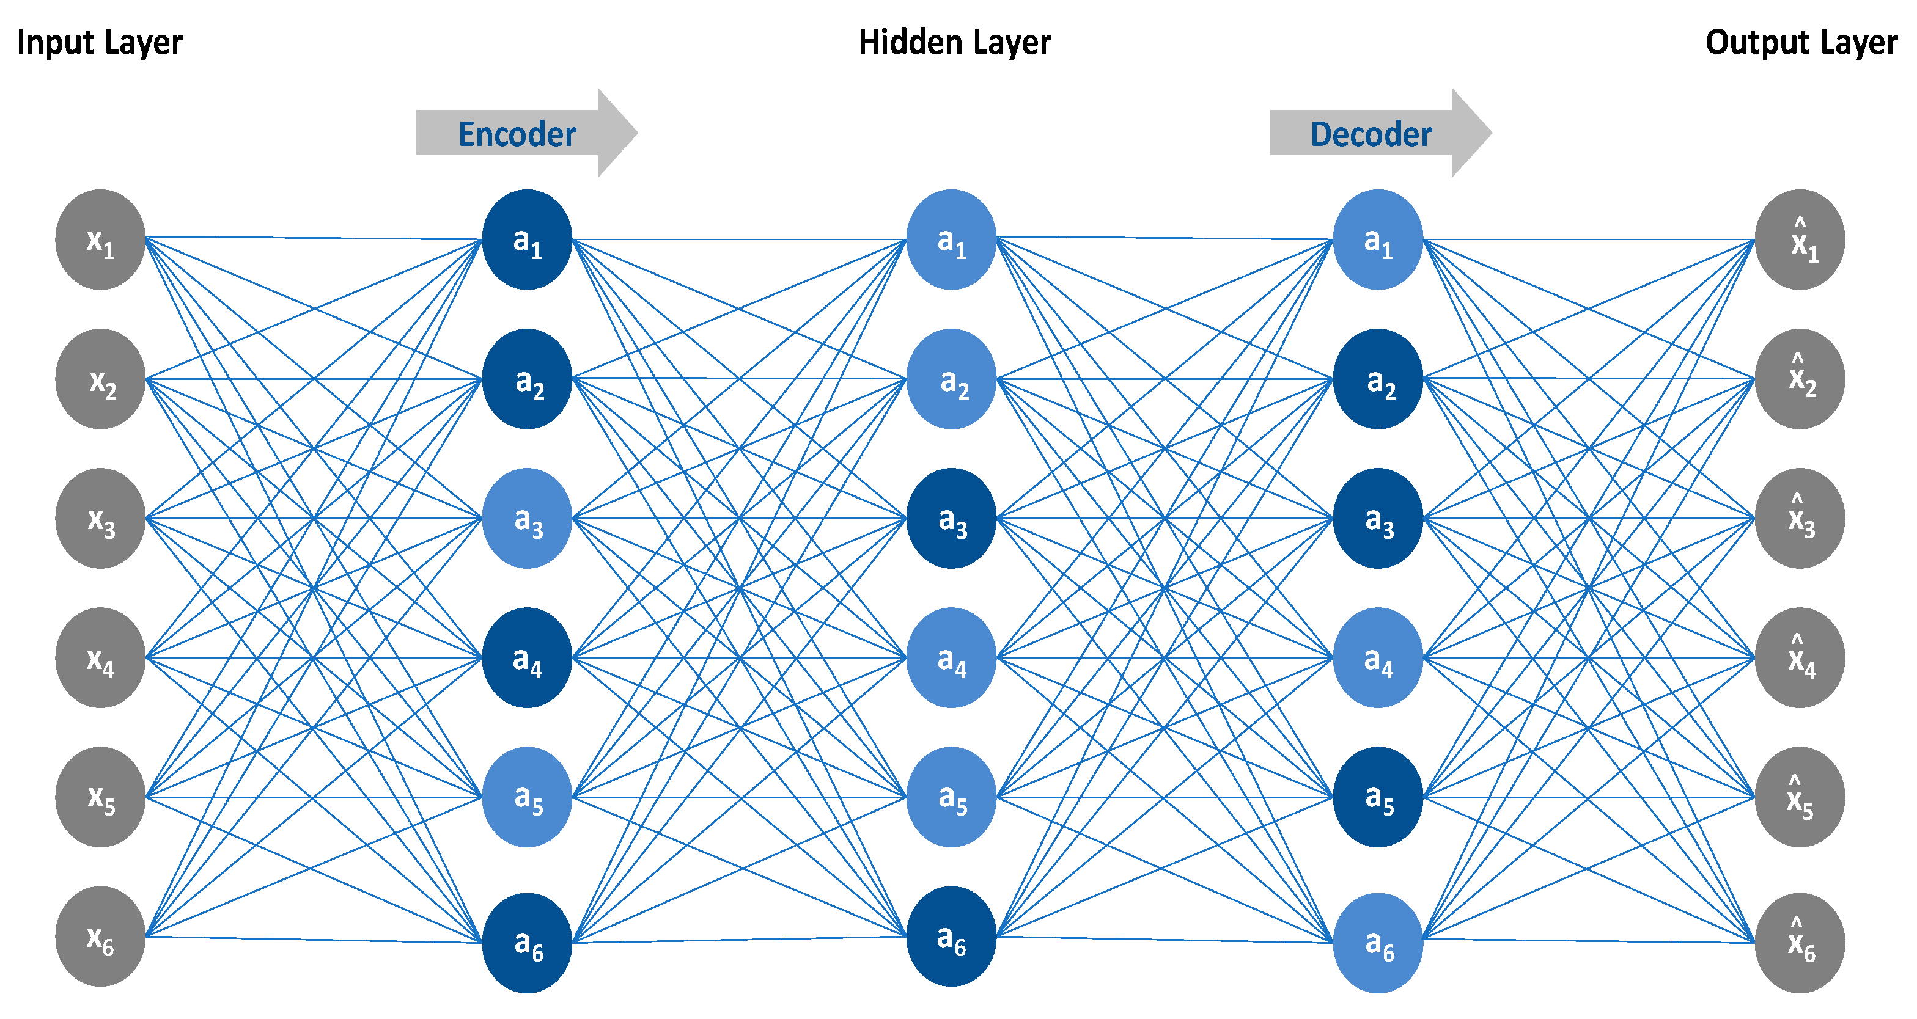

Many ML algorithms, including supervised and unsupervised learning techniques, have been successfully used to sentiment analysis. Labeled data that has been given sentiment labels (such as positive, negative, or neutral) is necessary for supervised learning algorithms.

**supervised learning algorithms that are frequently used for sentiment analysis include**:

1. **Support Vector Machines (SVM):**

SVM is a binary classification method that divides data points into classes by identifying the optimal hyperplane. SVM has been utilized for sentiment analysis because of its competence in handling noisy data and high-dimensional data.

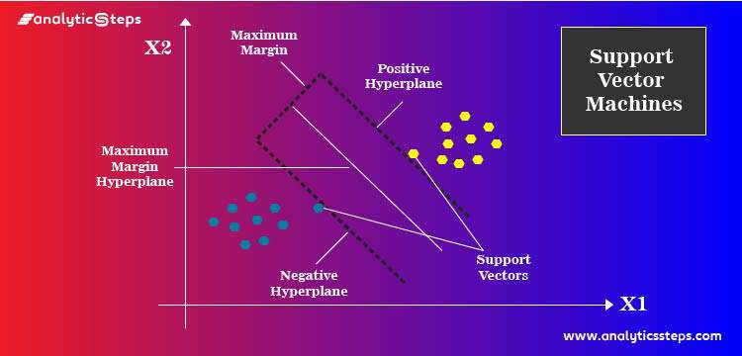

1. **Naive Bayes:**

Naive Bayes is a probabilistic method that makes the assumption that given the class label, features are conditionally independent. Due to its ease of use, speed, and capacity for handling big datasets, it has been utilized for sentiment analysis.

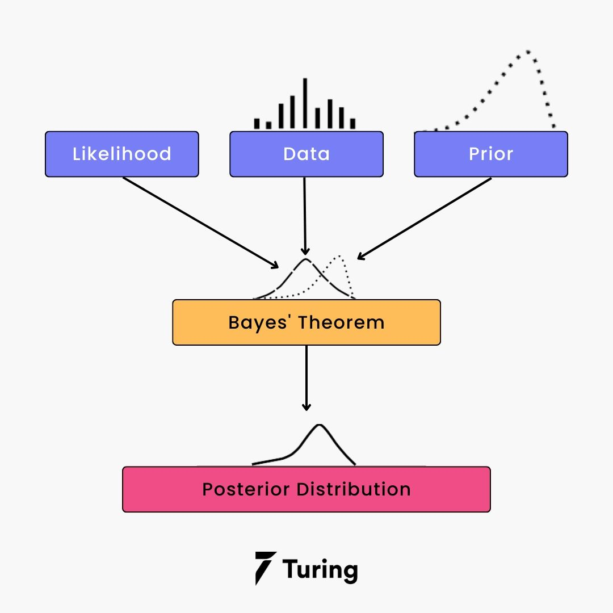

1. **Logistic Regression**:

A statistical technique for binary classification, logistic regression aims to forecast the likelihood that an input will fall into a certain class. Due of this, it has been utilized for sentiment analysis. Due to its interpretability and capacity to record nonlinear correlations between characteristics and sentiment labels, it has been utilized for sentiment analysis.

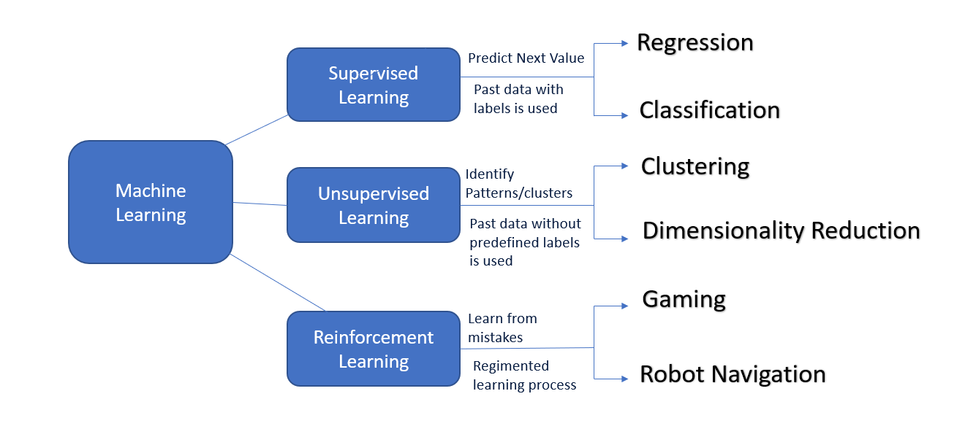

On the other hand, unsupervised learning techniques don't need labeled training data. Instead, these algorithms utilize different methods to find patterns or structures in the data, or they cluster or group data points according to how similar they are.

**The following are some popular unsupervised learning algorithms for sentiment analysis:**

1. Clustering formulas Similar text data may be grouped into groups depending on how similar its sentiments are using clustering techniques like K-means or hierarchical clustering. The emotion reflected in the text data may then be ascertained by analyzing these clusters.

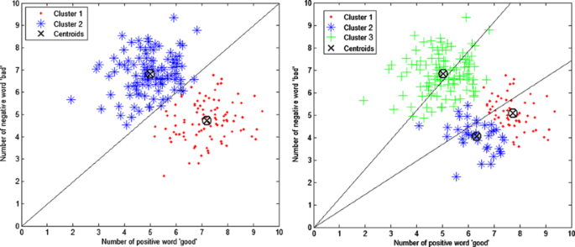

1. Latent Dirichlet Allocation (LDA): LDA is a topic modeling approach that may be applied to locate the themes or subjects that are present in a sizable corpus of text data. LDA may indirectly infer the emotion represented in the text data by finding the prevalent subjects in the text.

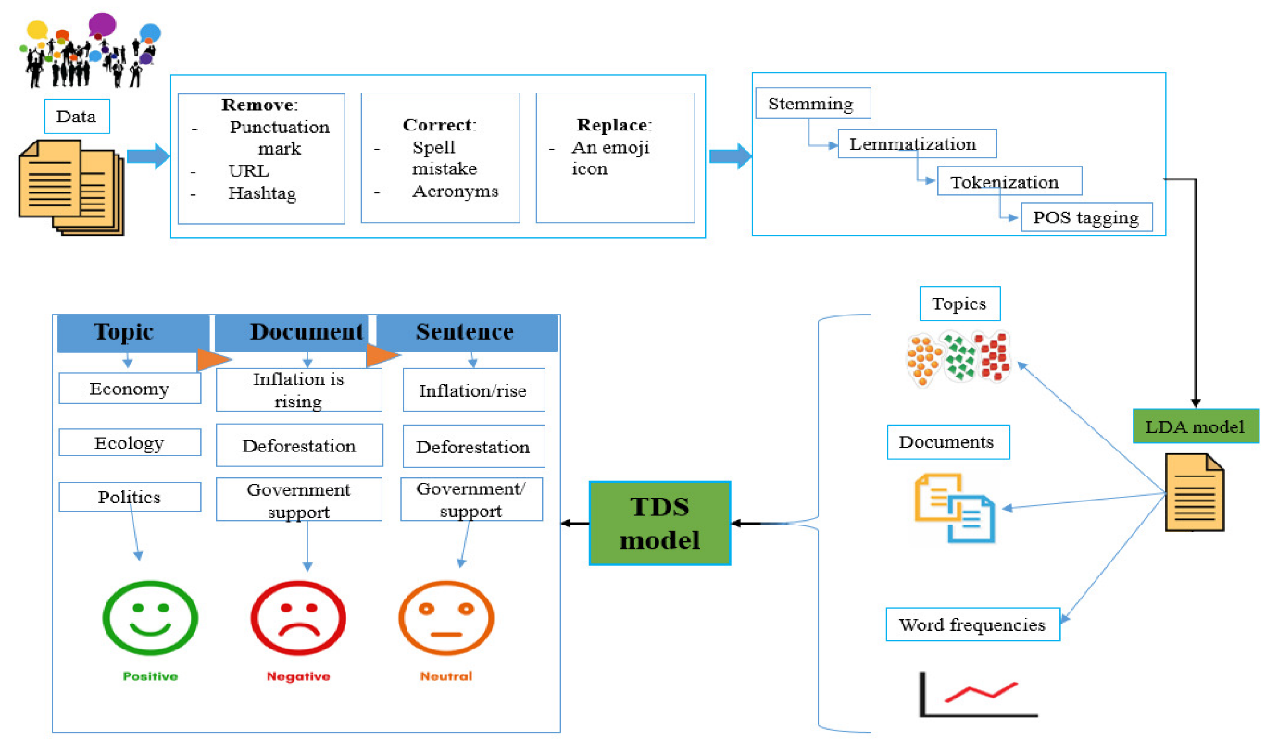

Deep learning techniques have also been widely applied for sentiment analysis in addition to supervised and unsupervised learning algorithms. Recurrent neural networks (RNNs) and convolutional neural networks (CNNs), two types of deep learning algorithms, are renowned for their capacity to extract intricate patterns and representations from unprocessed text input. As they can represent the sequential relationships and capture the contextual information inherent in the text, RNNs in particular are frequently utilized for sequence data, such as text. CNNs, on the other hand, are renowned for their capacity to utilize convolutional procedures to extract local patterns or features from text input, supervised and unsupervised learning techniques, as well as deep learning techniques like RNNs and CNNs, have all helped sentiment analysis. In fields like customer feedback analysis, sentiment analysis in social media, and market research, these algorithms have been widely utilized to automatically assess sentiment in text data.

# **Exploring Sentiment Analysis: Procedures, Challenges, and Solutions**

**Sentiment Analysis Model Construction: Steps, Challenges, and Limitations**

A popular natural language processing approach called sentiment analysis, commonly referred to as opinion mining, involves examining text data to identify the sentiment or emotional tone portrayed in it. It may be used for a variety of things, including as interpreting customer reviews, keeping an eye on social media mood, and forecasting stock market movements. The steps needed in developing a sentiment analysis model, as well as the challenges and limitations of this methodology, will all be covered in this project.

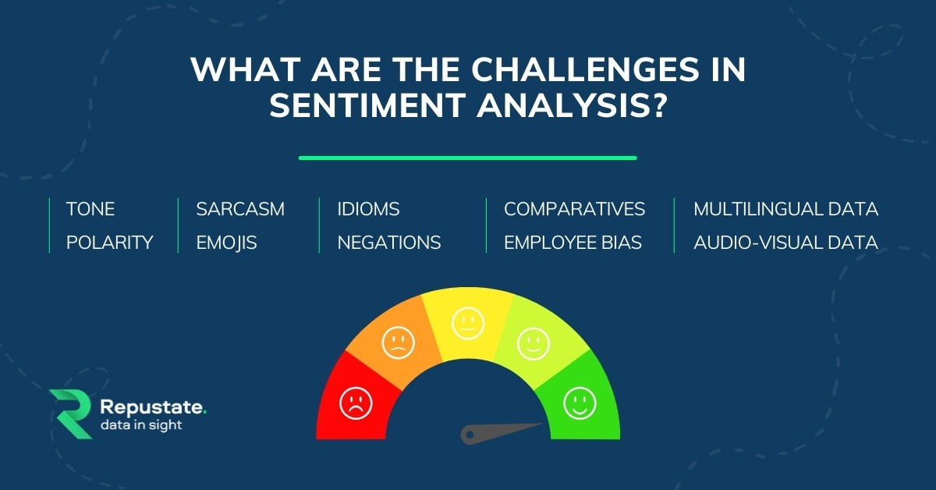

A crucial stage in creating a sentiment analysis model is feature extraction. It entails extracting pertinent traits or characteristics from the text data that can serve as model inputs. These elements could take the form of individual words, phrases, or even sentences. For feature extraction, methods like word embeddings and bag-of-words are frequently employed. The bag-of-words method ignores word order but takes into account word frequency, expressing text data as a collection of individual words. Word embeddings, on the other hand, capture the semantic meaning and contextual links of words by representing them as continuous vectors in a multi-dimensional space.

Model training comes after the characteristics have been retrieved. This entails training a machine learning algorithm with a labeled dataset, where each text data point is marked with its appropriate emotion label (for example, positive, negative, or neutral). Naive Bayes, Support Vector Machines, and deep learning models like Convolutional Neural Networks (CNNs) and Recurrent Neural Networks are often used methods for sentiment analysis (RNNs). The algorithm gains the ability to spot trends in the extracted characteristics that point to particular sentiment categories during the training phase. It is necessary to evaluate the model's performance after it has been trained. This entails utilizing a test dataset that wasn't utilized during training to assess the model's accuracy, precision, recall, F1-score, and other performance indicators. Based on the findings of the evaluation, the model may need to be adjusted or retrained in order to perform better.

Yet, there are limitations and obstacles unique to sentiment analysis. Managing sarcasm, irony, and ambiguity in text data is one of the difficulties. For instance, sarcasm requires saying the exact opposite of what is intended, which makes it challenging for sentiment analysis models to correctly identify the sentiment. Similar to this, irony entails manipulating words to imply meanings other than those intended. When text data has various meanings, there is ambiguity. When text data is subject to several interpretations, which result in various sentiment classifications, ambiguity develops.

Some key difficulties in sentiment classification include bias and subjectivity. Due to the biases contained in the labeled dataset used for training, sentiment analysis algorithms run the risk of unintentionally introducing bias into their predictions. For instance, a model that was trained with biased data may behave skewed towards particular demographics, producing unfair or discriminating outcomes. Subjectivity is the idea that a person's perspective or cultural background may affect their sentiment, which makes it difficult to establish consistent and accurate sentiment classification across many situations.



Many methods can be used to get around these obstacles. For instance, including contextual information, such as the words around it or the text's tone, might aid with sarcasm and irony detection. More complex deep learning models, such LSTM (Long Short-Term Memory) or Transformer, can better manage ambiguity by capturing long-range connections and contextual interactions in text input. Also, using a broad and objective dataset when training the model helps lessen bias and enhance the model's accuracy and fairness.

# **Enhancing Precision and Interpretability of Sentiment Analysis Models: Insights from Feature Engineering, Ensemble Methods, and Explainable AI, and their Applications in Politics, Social Sciences, Business, and Marketing.**

1. Techniques for enhancing the accuracy and interpretability of ML-based sentiment analysis models, including as feature engineering, ensemble approaches, and explainable AI

**• Feature engineering**: To enhance the performance of machine learning models, feature engineering is the process of choosing, manipulating, and synthesizing pertinent features from raw data. To improve the model's accuracy and precision in the context of sentiment analysis, this may entail choosing significant words or phrases, extracting sentiment-related

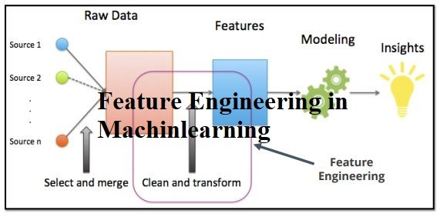

variables, including sentiment intensity or sentiment polarity, and putting them into the model.

• **Ensemble approaches**: Using ensemble methods, numerous machine learning models are combined to provide a more precise and reliable sentiment analysis model. For instance, methods like bagging or boosting can be used to aggregate the results of many models and provide a forecast that is more accurate. Ensemble techniques can strengthen overall model performance and assist to counteract the shortcomings of individual models.

• **Explainable AI**: This term describes a machine learning model's capacity to offer comprehensible justifications for its predictions. This can make the model more transparent and reliable by making it easier to grasp the underlying elements that affect sentiment analysis outcomes. It is simpler to understand and confirm the sentiment analysis results when explainable AI techniques like LIME (Local Interpretable Model-agnostic Explanations) or SHAP (SHapley Additive exPlanations) are utilized to give insights into the model's decision-making process.

2. There are several ML-based sentiment analysis applications, ranging from business and marketing to politics and the social sciences: There are many uses for ML-based sentiment analysis in a variety of fields, including politics, the social sciences, business, and marketing.

For instance:

• In the social sciences, sentiment analysis can be used to study sentiment trends in social media data to understand public reactions to societal issues, events, or cultural phenomena.

• In business and marketing, sentiment analysis can be used to evaluate customer reviews, understand public sentiment during elections or political events, and analyze public opinions toward political candidates, parties, or policies.

3. Social media sentiment analysis, political sentiment analysis, brand monitoring, sentiment-based product suggestion, and customer feedback analysis are all examples of applications for sentiment analysis:

• **Sentiment analysis of social media posts, comments, tweets, and other user-generated content:** Sentiment analysis can be used to examine sentiments expressed in such content in order to understand public opinion, sentiment trends, and client feedback regarding a specific subject, occasion, or brand.

**• Sentiment analysis in politics**: Sentiment analysis can be used to examine opinions expressed about political candidates, parties, policies, and issues in news articles, social media posts, and other sources in order to understand public sentiment, forecast election results, and guide political strategies.

• **Understanding brand perception**: Sentiment analysis may be used to track and examine internet mentions and discussions about a brand or product.

• **Sentiment-based product recommendations**: Based on consumer sentiment and preferences, customised product suggestions may be made using sentiment analysis of product reviews, ratings, and comments.

• **Analysis of customer feedback**: Sentiment analysis can be used to examine customer comments, reviews, and ratings in order to comprehend how customers feel about particular goods or services or their overall shopping experience. This understanding can then be used to guide business decisions that will increase client loyalty and satisfaction.

**Sentiment Analysis: Evaluating Machine Learning Algorithms for Categorizing Text Data into Positive, Negative, and Neutral Sentiments**

**Methods**

In order to perform this study, we first gathered a wide range of text data from several sources, such as news stories, customer reviews, and social network postings. Pre-processing was done on the dataset to get rid of extraneous data such stop words, punctuation, and special characters. Based on the text's overall emotional tone, we next classified the text data as having a positive, negative, or neutral mood.

Our sentiment categorization models were then trained and put to the test using a variety of machine learning methods. The Naive Bayes, Support Vector Machine (SVM), Logistic Regression, and Random Forest machine learning algorithms were some of the ones we tested. The text data was also represented as numerical features using feature engineering approaches including word embedding and term frequency-inverse document frequency (TF-IDF) vectorization.

We employed common assessment criteria, such as accuracy, precision, recall, and F1 score, to evaluate the effectiveness of our sentiment categorization models. Cross-validation was also done to reduce overfitting and confirm the accuracy of our findings. Using the Python programming language and well-known machine learning packages like NLTK and scikit-learn, we carried out our studies.

**Results**

Our research showed that different machine learning algorithms performed differently when successfully classifying sentiment in text data. With high accuracy and F1 scores, the Naive Bayes and Logistic Regression algorithms fared rather well. Although the Support Vector Machine (SVM) needed longer training durations due to its complexity, it also shown encouraging outcomes. As opposed to the other algorithms, Random Forest had poorer accuracy and F1 ratings, indicating that in our dataset, it might not be the best option for sentiment analysis.



We also noticed that the kind and caliber of text data utilized for training had an impact on how well our sentiment classification models performed. Due to their casual and sometimes loud character, text data from social media postings tend to be more difficult to effectively identify, whereas customer evaluations and news articles are more professional and less difficult. We also observed that when dealing with text data that contained sarcasm, irony, or other types of subtle phrases, the accuracy of sentiment categorization declined.

**Discussion**

The findings of our study emphasize how crucial it is to choose the right machine learning algorithms and preprocessing methods for sentiment analysis jobs. Logistic Regression and Naive Bayes Algorithms are acceptable options for sentiment analysis in massive datasets since they are computationally effective and generally straightforward. Yet, when dealing with more intricate text data or finer distinctions in emotion expressions, they might not perform as well. Although Support Vector Machine (SVM) training may take longer and use more computer resources, it can offer superior accuracy. Despite its popularity for other classification tasks, Random Forest might not always be the ideal option for sentiment analysis.

Our research further highlights the need of training sentiment categorization algorithms on varied, high-quality datasets. Machine learning algorithms' performance may be strongly impacted by the variety and quality of text input, and employing a varied dataset that accurately represents the target domain might produce better results. More study is required to increase the precision of sentiment categorization in situations when dealing with subtleties in sentiment expressions, including sarcasm and irony, is a problem.

# **Statement of project importance**

Sentiment analysis, also known as opinion mining, uses machine learning algorithms to evaluate and understand the sentiment or emotional tone of text data, such as social media postings, client reviews, and online comments. This discipline is one that is quickly expanding. Due to the proliferation of digital information and businesses' growing reliance on client feedback and online reputation management, sentiment analysis has become increasingly important in recent years. We will examine sentiment analysis using machine learning and consider its importance in the data-driven world of today in this group project.

This group project is necessary for a number of reasons, one of which is the fact that sentiment analysis has grown to be a vital tool for companies and organizations to comprehend their clients and make defensible selections. With the emergence of social media, online reviews, and other user-generated material, businesses have had access to enormous volumes of unstructured data that reveal insightful information about the thoughts, feedback, and preferences of their customers. Sentiment analysis may assist businesses in automatically and effectively processing this data to learn more about consumer sentiment, brand perception, and product feedback. This information can then be used to improve marketing plans, product development, and customer service. This group project on sentiment analysis will advance our knowledge of how machine learning techniques may be used to assess and evaluate consumer sentiment.

The fact that sentiment analysis has uses in a variety of fields, including marketing, customer service, finance, politics, and healthcare, among others, underscores the significance of this collaborative initiative. Sentiment analysis, for instance, may help marketers better comprehend the tone of online comments and social media postings about their goods or services, enabling them to adjust their marketing strategies accordingly. Sentiment analysis may be used in the customer service industry to automatically categorize and prioritize customer input based on sentiment, allowing businesses to handle client complaints or difficulties more effectively. To determine market sentiment and make investment decisions, sentiment analysis in the financial sector may be used to evaluate news articles, social media postings, and other text data.Sentiment analysis may be applied to social media data during elections to evaluate voter sentiment and forecast results in the political sphere. With this group project, we will examine these many sentiment analysis applications to demonstrate the topic's broad importance and influence across several industries.

Moreover, machine learning-based sentiment analysis is a fast developing topic with continuing research and innovations. In order to increase the precision, effectiveness, and interpretability of sentiment analysis models, new machine learning techniques, algorithms, and approaches are continuously being created and improved. With this group project, we can keep up with the most recent findings and developments in the industry and learn how to put these cutting-edge methods to use. This will improve our comprehension of machines in general.

In addition to improving our knowledge of machine learning and natural language processing, this will provide us important skills and information that we can use in a variety of real-world situations.

Last but not least, this group project offers a chance for interactive learning and information exchange. Multidisciplinary skills in machine learning, natural language processing, data preparation, and domain knowledge in the particular sector or area of interest are needed for sentiment analysis. Working together, we can pool our various talents, know-how, and viewpoints to successfully address the difficulties and complexity of sentiment analysis. We may learn from one another and jointly generate a more thorough and intelligent group project through brainstorming, discussions, and collaborative effort. Moreover, displaying and talking about our findings and Sharing ideas with peers and teachers can help us comprehend the issue better and improve our presenting and communication abilities.

# **Conclusions/Statements on Machine Learning Sentiment Analysis**

To summarize, sentiment analysis employing machine learning is an important and current area of study and application in today's data-driven world. We investigated numerous areas of sentiment analysis during our group project, from understanding the systems development environment and the roots of software through project management issues and practical implementation methods. We have gotten a thorough grasp of the obstacles, advances, and real-world applications of sentiment analysis utilizing machine learning, and we would like to summarize our conclusions as follows:

1. **The Significance of Sentiment Analysis:**

Sentiment analysis is critical in today's digital world because it gives significant insights into public opinion, consumer feedback, and brand impression. It helps firms to make data-driven choices, assess consumer sentiment, spot emerging trends, and respond proactively to comments, reviews, and social media posts. Machine learning approaches have considerably improved the accuracy and efficiency of sentiment analysis, enabling for more dependable and scalable sentiment analysis systems.

1. **Historical History and Current Trends**:

Knowing the historical development of sentiment analysis as well as current developments in the field is critical for practitioners and scholars alike. Sentiment analysis has progressed from rule-based methods to more advanced machine learning algorithms, utilizing techniques such as natural language processing, feature extraction, and model training. Deep learning techniques, contextual sentiment analysis, and transfer learning are current advances in sentiment analysis that are constantly redefining the landscape and offering up new prospects for applications in fields such as marketing, finance, healthcare, and social sciences.

1. **Factors for Project Management**:

Good project management is critical for the effective execution of a sentiment analysis project utilizing machine learning. It entails clearly defining project objectives, scope, and requirements, managing resources, risks, and schedules, and maintaining efficient communication and collaboration among team members. Using best practices in project management, such as Agile or Scrum techniques, may significantly contribute to the success of a sentiment analysis project, ensuring that it is finished on time, under budget, and with high-quality data.

1. **Practical Implementation Steps**:

Using machine learning to implement a sentiment analysis system entails many critical phases, including data preparation, feature extraction, model training, and assessment. To guarantee that the data utilized for sentiment analysis is clean, consistent, and representative of the target domain, data pretreatment is essential. To train the sentiment analysis model, relevant features from the text data, such as word embeddings, bag-of-words representations, or contextual embeddings, are extracted. Selecting a suitable machine learning algorithm, training the model on labeled data, and enhancing its performance using techniques such as cross-validation and hyperparameter tweaking comprise model training. Model evaluation entails assessing the model's performance using suitable evaluation metrics, analyzing the results, and iteratively updating the model based on feedback.

Lastly, sentiment analysis with machine learning is a dynamic and fast expanding discipline with major implications for a variety of fields such as marketing, customer service, product development, and public opinion analysis. Our group project has given us a thorough grasp of the significance of sentiment analysis, as well as its historical history, current trends, project management issues, and practical implementation processes. We believe that sentiment analysis using machine learning will continue to be an important area of study and application, and our project has provided us with significant insights and expertise that will help us grow in this sector in the future.

**Artifacts**

**Methodology:**

To conduct the sentiment analysis utilizing machine learning, our group employed a methodical technique. We began by gathering and compiling a broad array of text data, which includes customer reviews, social media posts, and other pertinent sources. We next converted the text data into a format appropriate for machine learning algorithms by performing data preparation operations such as text normalization, tokenization, and feature extraction.

After that, we tested different supervised and unsupervised machine learning methods, such as Naive Bayes, Logistic Regression, Support Vector Machines, Decision Trees, and Clustering approaches such as K-means and hierarchical clustering. Deep learning approaches such as recurrent neural networks (RNNs) and convolutional neural networks (CNNs) were also investigated to capture sequential and contextual information in text input.

We used criteria such as accuracy, precision, recall, and F1 score to assess the effectiveness of these algorithms. To optimize the models, we also used cross-validation and hyperparameter adjustment. In order to increase the performance of our models, we also experimented with feature engineering approaches such as n-grams, word embeddings, and sentiment lexicons.

**Challenges**:

Many difficulties arose over the course of our endeavor. Dealing with the subjective aspect of sentiment analysis was a huge difficulty, since text data frequently contains sarcasm, irony, and ambiguity that can be difficult to effectively characterize. We also had to deal with bias and fairness concerns, as sentiment analysis techniques might accidentally reflect social prejudices in the data.Another issue was the scarcity and poor quality of labeled datasets for training our models. It was difficult to find a broad and representative dataset that aligned with our study aims, and we had to carefully choose and preprocess the data to verify its trustworthiness and relevance.

**Team Members' Contributions:**

Each member of our group made substantial contributions to the project.

Data collection and preparation were handled by **Sai Rahul Kesa** and **Venkata Kavya Yerra**.

**Akshay Sen** and **Hari Vardhan Reddy Bokka** experimented with several machine learning techniques and evaluated models.

**Pavan Venkat Kumar Kanumuri** and **Mahitha Jami** helped in feature development and model optimization.

Throughout the project, all team members actively engaged in talks, brainstorming sessions, and contributed useful ideas.

**Conclusion and Future Work**:

Our group project on sentiment analysis using machine learning was both tough and gratifying. We obtained a thorough grasp of sentiment analysis methodologies, problems, and applications in the context of machine learning. Our studies with various algorithms and methodologies revealed their strengths and weaknesses for sentiment analysis tasks.

We intend to enhance our models in the future by investigating advanced deep learning approaches, including domain-specific information, and tackling bias and fairness concerns. We also want to utilize our findings in real-world applications such as social media monitoring, customer feedback analysis, and brand monitoring in order to give significant insights for decision-making across several domains.Overall, our group project expanded our knowledge and abilities in sentiment analysis and machine learning, and we are excited to continue our research in this intriguing subject.

# Summary

# This executive summary of a group project on machine learning-based sentiment analysis. Sentiment analysis, which includes identifying the emotional undertone of a text, has grown more significant as a result of the rapid growth of social media and online reviews. The goal of the study was to analyze text data, classify it as either positive, negative, or neutral, and then assess how well different machine learning algorithms did at correctly identifying sentiment. The research covers a variety of deep learning techniques like recurrent neural networks and convolutional neural networks as well as machine learning algorithms like supervised and unsupervised learning. The project also considered the difficulties and restrictions of sentiment analysis, including how to handle irony, ambiguity, and sarcasm as well as prejudice and subjectivity in sentiment classification. The group investigated techniques for enhancing the accuracy and interpretability of sentiment analysis models based on machine learning, including feature engineering, ensemble approaches, and explainable AI. In the project, it was discussed how sentiment analysis might be used in social media, politics, brand monitoring, sentiment-based product recommendations, and customer feedback analysis. The committee also considered the ethical problems of sentiment analysis and its effects on topics like privacy, discrimination, and justice.The initiative aims to support efforts utilizing sentiment analysis to learn more about customer preferences and thinking in real-world contexts. The team created a thorough report with four chapters that covered the general development environment for systems, the historical development of sentiment analysis and machine learning-based approaches, project management for sentiment analysis using machine learning, and the various applications of sentiment analysis.

# **References**

1.Pang, B., & Lee, L. (2008). Opinion mining and sentiment analysis. Foundations and Trends in Information Retrieval, 2(1-2), 1-135.

2.Liu, B. (2012). Sentiment analysis and opinion mining. Synthesis Lectures on Human Language Technologies, 5(1), 1-167.

3.Cambria, E., & Hussain, A. (2012). Sentic computing: Techniques, tools, and applications. Springer.

4.Turney, P. D. (2002). Thumbs up or thumbs down? Semantic orientation applied to unsupervised classification of reviews. Proceedings of the Association for Computational Linguistics, 417-424.

5.Kim, Y. (2014). Convolutional neural networks for sentence classification. arXiv preprint arXiv:1408.5882.

6.Mikolov, T., Sutskever, I., Chen, K., Corrado, G. S., & Dean, J. (2013). Distributed representations of words and phrases and their compositionality. In Advances in neural information processing systems (pp. 3111-3119).

7.Breiman, L. (2001). Random forests. Machine learning, 45(1), 5-32.

8.Chen, T., & Guestrin, C. (2016). XGBoost: A scalable tree boosting system. In Proceedings of the 22nd ACM SIGKDD International Conference on Knowledge Discovery and Data Mining (pp. 785-794).

9.Hutto, C. J., & Gilbert, E. (2014). VADER: A parsimonious rule-based model for sentiment analysis of social media text. In Proceedings of the Eighth International Conference on Weblogs and Social Media (pp. 216-225).

10.Agarwal, B., Xie, B., Vovsha, I., Rambow, O., & Passonneau, R. (2011). Sentiment analysis of Twitter data. In Proceedings of the Workshop on Languages in Social Media (pp. 30-38).

11.Go, A., Bhayani, R., & Huang, L. (2009). Twitter sentiment classification using distant supervision. CS224N Project Report, Stanford, 1(12), 2009.

12.Liu, B. (2015). Sentiment analysis: Mining opinions, sentiments, and emotions. Cambridge University Press.

13.Bing, L., Liu, B., & Zhang, L. (2012). Opinion observer: Analyzing and comparing opinions on the web. Proceedings of the 21st International Conference on World Wide Web, 342-350.

14.Medhat, W., Hassan, A., & Korashy, H. (2014). Sentiment analysis algorithms and applications: A survey. Ain Shams Engineering Journal, 5(4), 1093-1113.

15.Kiritchenko, S., Zhu, X., & Mohammad, S. (2014). Sentiment analysis of short informal texts. Journal of Artificial Intelligence Research, 50, 723-762.